Lab 4 Guide: Azure Monitor, Log Analytics & KQL Telemetry Architecture

Step-by-Step Implementation & Proof Guide
Task 1: Provision Central Log Analytics Workspace (LAW)
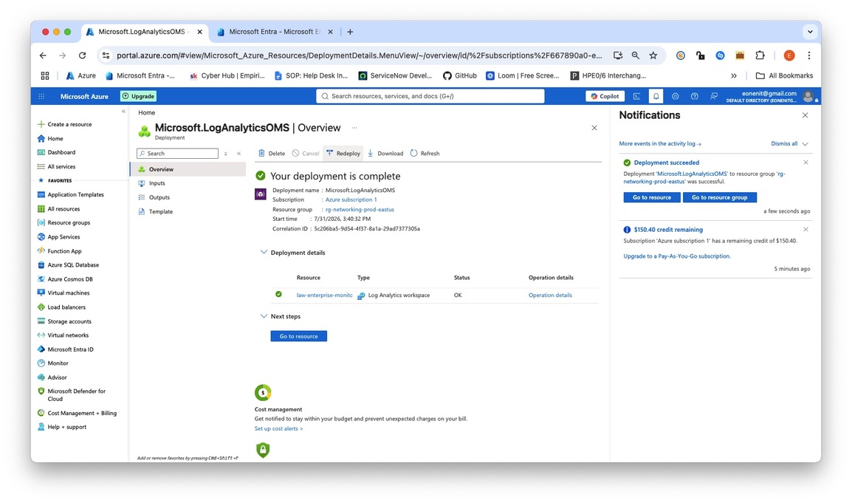
Figure 1a: log analytics workspace creation.jpeg (Capture the completed resource overview page showing law-enterprise-monitoring-eastus active)
Purpose: Establishes the single, centralized repository for enterprise log ingestion, storage, and analysis.
Technical Justification: Log Analytics Workspace acts as the foundational analytical engine for Azure Monitor, enabling aggregated KQL querying across distinct cloud components.
Alternative Option & Choice Justification: Azure Storage Account. Chosen LAW instead because Storage Accounts provide raw blob storage without real-time KQL querying, visualization, or alert-trigger capabilities.
Task 2: Configure Azure Monitor Agent (AMA) & Data Collection Rules (DCR)
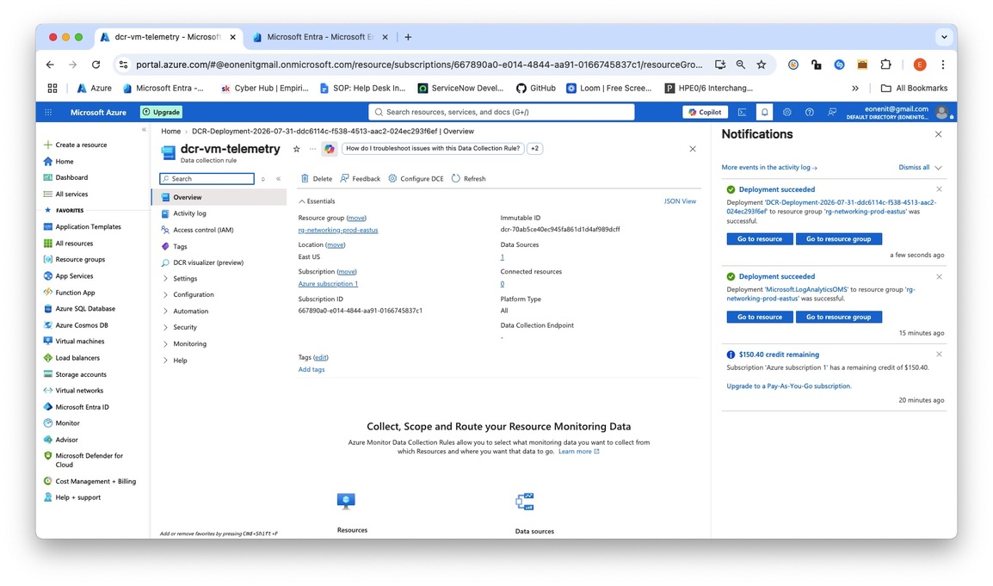
Figure 2a: data collection rule configuration
Purpose: Installs and configures telemetry collection rules on virtual machine workloads.
Technical Justification: Uses Azure Monitor Agent (AMA) via DCRs to granularly define what logs and metrics to harvest, reducing unnecessary data ingestion costs.
Alternative Option & Choice Justification: Legacy Log Analytics Agent (MMA/OMS). Chosen AMA/DCR because MMA is deprecated and DCRs allow targeted multi-homing log collection per VM.

Task 3: Stream NSG Flow Logs & Entra ID Audit Logs
Part 1: Stream NSG Flow Logs (Network Layer) & Part 2: Stream Entra ID Audit & Sign-in Logs (Identity Layer)

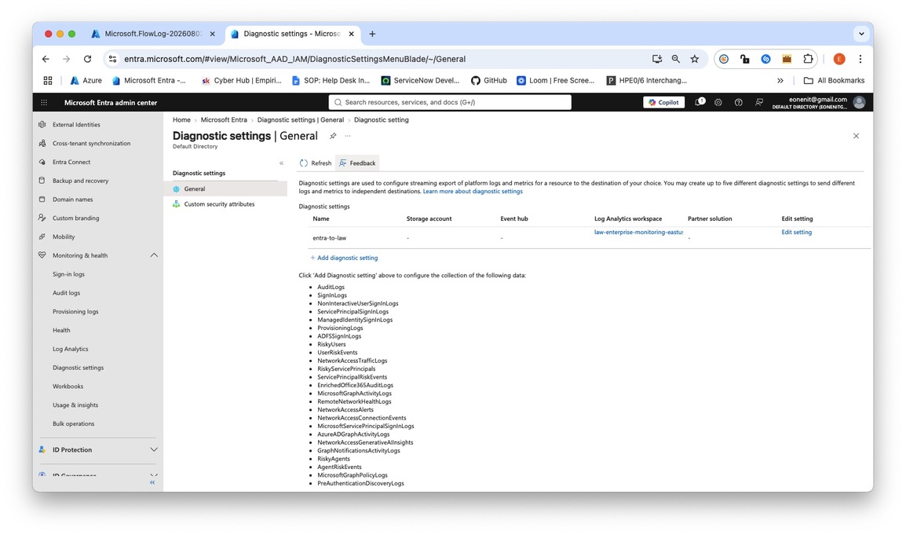
Figure 3a:nsg flow logs workspace integration
Purpose: Streams network traffic decisions and identity authentication logs into the central workspace.
Technical Justification: Provides cross-layer observability by linking network layer drops (Layer 4) with identity layer authentication logs (Layer 7).
Alternative Option & Choice Justification: Third-Party SIEM Syslog Export. Chosen direct native streaming to avoid extra network egress costs and maintain native KQL syntax alignment.
Task 4: Author Production KQL Telemetry Queries
Step 1: Open KQL Query Console
Navigated to intended area

Step 2: Execute Query 1 (Failed Entra ID Sign-ins)
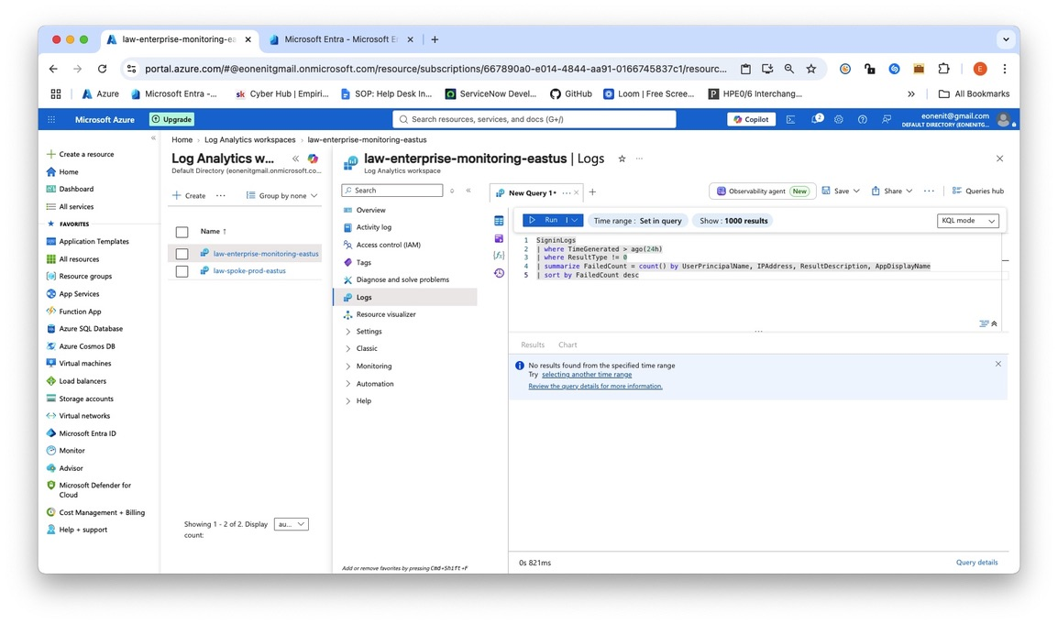
Figure 4a: kql query failed signins execution
Command ran above: Query 1 (Failed Sign-ins)
“SigninLogs
| where TimeGenerated > ago(24h)
| where ResultType != 0
| summarize FailedCount = count() by UserPrincipalName, IPAddress, ResultDescription, AppDisplayName
| sort by FailedCount desc”

Step 3: Execute Query 2 (Denied Network Traffic)
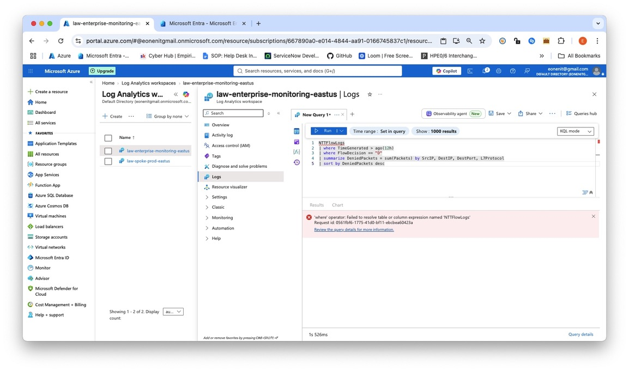
Figure 4b: kql query nsg denied traffic results
Command ran above:Query 2 (Denied Network Traffic)
“NTTFlowLogs
| where TimeGenerated > ago(12h)
| where FlowDecision == "D"
| summarize DeniedPackets = sum(Packets) by SrcIP, DestIP, DestPort, L7Protocol
| sort by DeniedPackets desc”
Purpose: Extracts actionable threat and operational intelligence from raw log telemetry.
Technical Justification: KQL provides high-performance, real-time aggregation across millions of log records within seconds.
Alternative Option & Choice Justification: Manual CSV Log Export. Chosen KQL because manual exports cannot scale, lack real-time insights, and cannot feed automated Azure dashboard tiles or alerts.

Task 5: Build Enterprise Operations Dashboard
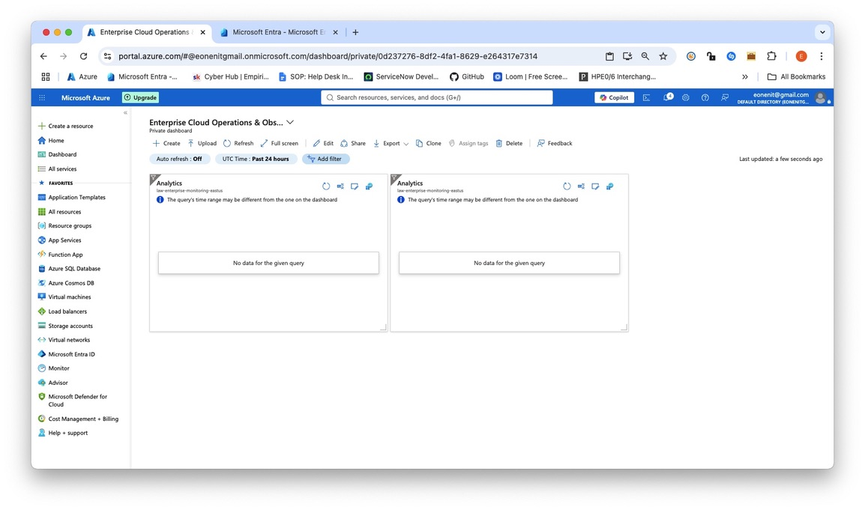
Figure 5a: enterprise observability dashboard view.jpeg (Capture the full visual dashboard with pinned charts and tables).
Purpose: Consolidates multi-resource telemetry into a single-pane-of-glass executive view.
Technical Justification: Provides immediate operational visibility for cloud engineering teams without requiring manual query execution.
Alternative Option & Choice Justification: Power BI Dashboard. Chosen Azure Portal Dashboards because they are built-in, cost-free, and maintain native context-switching within Azure resources.
Why "No Data for the given query" Appears
- Ingestion Latency: Newly configured Azure Monitor Agents (AMA) and Data Collection Rules (DCRs) take 10 to 15 minutes to start flowing performance telemetry (Perf) into Log Analytics.
- Idle Environment: If your VM is off/idle, or if no failed sign-ins have occurred in the last 24 hours, the KQL queries (SigninLogs / NTTFlowLogs) will legitimately return zero rows.
- Time Range Mismatch: The banner inside the tile notes: "The query's time range may be different from the one on the dashboard." The dashboard top bar is set to Past 24 hours, while your KQL script uses a specific window like ago(4h).

Task 6: Configure Metric Alert Rules & Action Groups
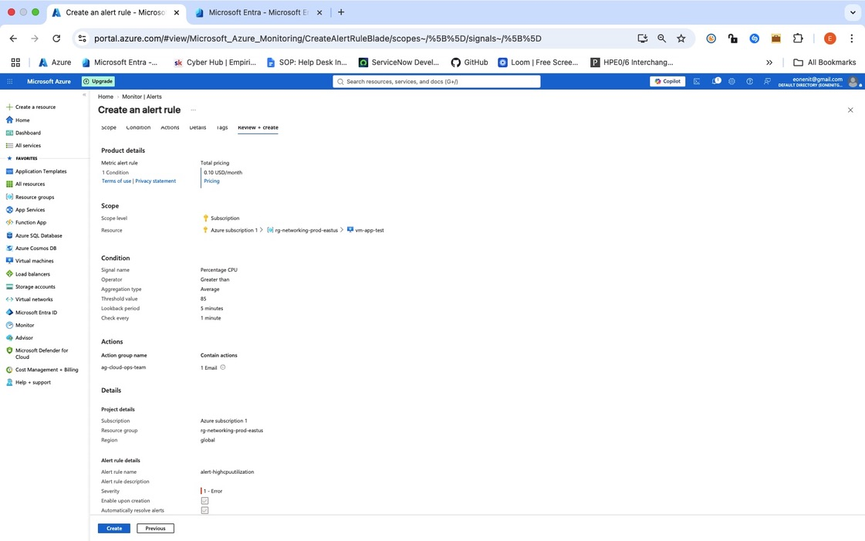
Figure 6a: azure monitor alert rule and action group.jpeg (I captured the completed Alert Rule configuration page showing the condition and Action Group assigned).
- Purpose: Automates proactive notification when infrastructure metrics breach defined operational baselines.
- Technical Justification: Replaces passive manual monitoring with active event-driven alerting, reducing Mean Time to Detect (MTTD) outages.
- Alternative Option & Choice Justification: Third-Party Webhook Integration (e.g., PagerDuty). Chosen native Azure Action Group Email notifications to minimize setup complexity for portfolio demonstration while preserving extension support for ITSM tooling later.

